Logistics & Infrastructure of Commerce

Southeast Asia & Vietnam

-- SeenPay --

1. **Ground delivery and shipping services:**
2. **Air & Railroad delivery and shipping services:**
3. **Consumer’s behavior on delivery and shipping services in Vietnam:**
4. **Prediction of Logistics service in Vietnam:**
5. **The improvement of Logistics affecting e-commerce:**

*Infrastructure (airports, seaports, roads, bridges, etc.) are all important to a country in terms of attracting investment and business and to a company when it is time to decide where to locate an investment, build a factory, establish a regional office, etc. How easy a country is to travel to and the modernity and efficiency of its air and seaports is always something a company and its executives need to consider. Asia is growing fast and infrastructure in terms of air and seaports is constantly changing. Below are insights on logistical key installations throughout the region.*

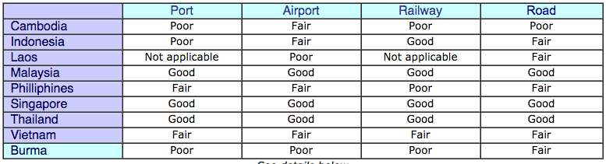

1. **Ground delivery and shipping service:**

* Vietnam's population has variety of options when it comes to shipping/delivering to 63 cities/provinces in Vietnam. The most common way among land, air and sea is ground shipping, by using any form of land vehicle from motorcycles to buses to lorries . According to our research, Vietnam’s poor infrastructure is the primary cause due to the lack of strategic planning i.e efficient road systems and the absence of qualified professional express delivery companies. To be more specific, the majority of Vietnamese prefer choosing to pay for delivering using buses. This method have been around for more than 60 years. It’s considered the cheapest way when transporting bulk goods because these buses also carry passengers at the same time. This kind of shipping relies on a significant amount of trust between customer and bus company, since they do not guarantee or any assurance that the good could be damaged or lost, in other words stolen.
* Good area coverage is what ground shipping in Vietnam can offer. With more than 200 bus companies and express companies, customers have lots of options to get fastest service that they want. ----- “contradicts”

1. **Air, railroad delivery & shipping service:**

Air services is still an expensive service for Vietnamese consumers as whole. It needs a lot of applications, not always on time are just some of the words that describe about air and rail road shipping service conditions. Despite that, they guarantee accurate shipment delivery, short time of transition and reliable. The major users of Air delivery in Vietnam is from large cities due to the higher income and higher demand.

1. **Consumer’s behavior on delivery and shipping services in Vietnam:**

Cash payment up front and meeting face to face is the Vietnamese culture in business. They also prefer to buy things locally. To them, shipping only becomes necessary when the value of item is low or if it’s too big to carry in person. As a matter of fact, the Vietnamese customer service standards in any sector is still very poor and inconvenient when resolving issues.

1. **Prediction of Logistics service in Vietnam:**

Reports show that, Vietnam has the fastest infrastructure improvement in South east Asia but the reason is because Vietnam has been struggling for a longer time than others. The shipping companies have to improve their services to create more customers, to make them feel safer when using the services.